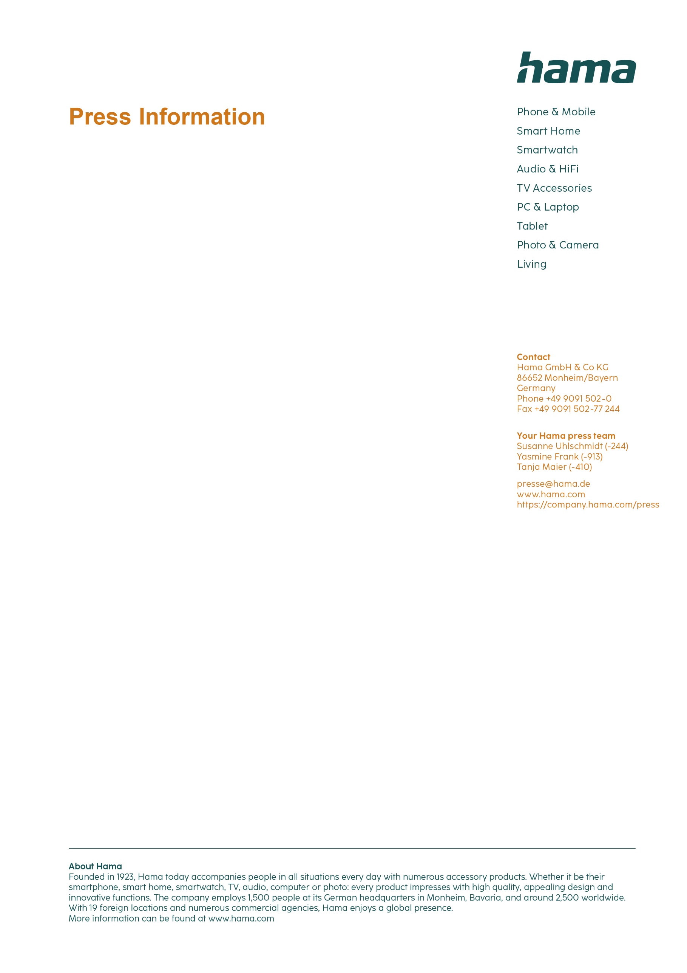
November 2024

For exceptional perspectives in the best light

"SpotLight FoldUp RGB 102" LED RGB Ring Light

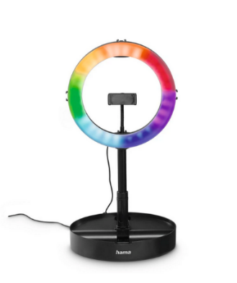
Whether it's product photography or a make-up tutorial: with the "SpotLight FoldUp RGB 102" Hama LED RGB ring light, everything shines in the right light. The lamp scores with 29 different RGB modes for unique lighting moods. The colour temperature itself can be adjusted in three steps from warm white to daylight bright via the cable remote control for optimum illumination of videos and portraits, while the light intensity can even be adjusted in nine steps (or eight steps in RGB mode) from radiantly bright to pleasantly dimmed. The integrated Charming Eye effect makes your eyes sparkle.

Ideal travelling companion

Thanks to its variability, the ring light cuts a fine figure anywhere. Whether folded up small in a suitcase, or extended to a full 138 centimetres or as a 52-centimetre table stand for make-up tutorials: more flexibility is hard to find.
It can also be operated using a power pack or USB power supply unit, making it even more location-independent. With the ball head and the flexible gooseneck, the smartphone can be orientated as desired - whether in portrait or landscape format. Plenty of connections with ¼-inch or cold shoe round off the features of the Hama "SpotLight FoldUp RGB 102" LED RGB ring light.

Item No. 4665 "SpotLight FoldUp RGB 102" LED-RGB Ring Light

Printable graphics data are available for download in our internet press club
https://company.hama.com/press

