Press Information
Hall 4.2, Booth no. 147
Phone & Mobile
Smart Home
Wearables
Audio & HiFi
TV Accessories
PC & Laptop
Tablet
Photo & Camera
Living

Contact
Hama GmbH & Co KG
86653 Monheim/Bayern
Germany
Phone +49 9091 502-0

Your Hama press team
Yasmine Frank (-913)
Tanja Maier (-410)
presse@hama.de
https://company.hama.com/press



Small, sleek, and barely noticeable

Hama Brings Health Tracking to Your Finger

For those who want to keep track of their health data but don’t want to wear a smartwatch, Hama’s new “Ring One” offers an exciting alternative. The smart ring is designed for anyone who wants to use fitness and health features as discreetly as possible—all wrapped up in a simple, minimalist design.
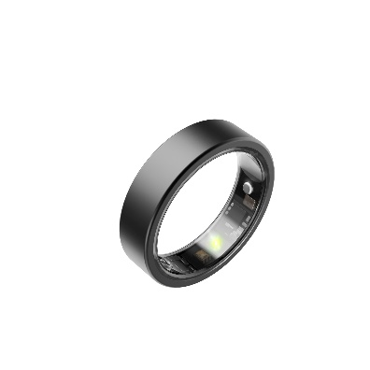
With the “Ring One,” Hama is tapping into a trend that also shapes the company’s Connect Story: Connected technology should provide guidance rather than overwhelm users. In the context of longevity, the Ring helps make health data understandable and accessible for everyday use—discreetly, continuously, and without the need for constant screen use.
Despite its compact size, the stainless steel ring is packed with technology. It monitors heart rate, heart rate variability, and blood oxygen saturation around the clock. It also measures body temperature and analyzes sleep to provide insights into nighttime recovery.

All recorded health and activity data can be analyzed for free in the Hama Active app—with no subscription or additional costs for individual features.
Fitness Tracking Without Compromises
Phone & Mobile
Smart Home
Wearables
Audio & HiFi
TV Accessories
PC & Laptop
Tablet
Photo & Camera
Living

Contact
Hama GmbH & Co KG
86653 Monheim/Bayern
Germany
Phone +49 9091 502-0

Your Hama press team
Yasmine Frank (-913)
Tanja Maier (-410)
presse@hama.de
https://company.hama.com/press

Sports fans will also find it to their liking: The Ring supports 120 different sports, counts steps, and accompanies its wearers through their active daily lives. Thanks to its 5 ATM water resistance, it can even be worn while swimming without any problems. A handy extra feature designed specifically for women is the built-in cycle tracker, which helps with planning and tracking the menstrual cycle.

Subtly Informative
Notifications are signaled directly on your finger via vibration. This ensures that important messages don’t go unnoticed, without a display constantly drawing your attention. The battery lasts up to four days before the ring needs to be recharged.

The Hama “Ring One” is available in U.S. ring sizes 7 through 12.

At a Glance
Item Number: 178643-52
Name: “Ring One” Smart Ring
Key Features: Vibration notifications, health monitoring, waterproof

Item No. 178643-52 Smart Ring “Ring One”

Printable graphics data are available for download in our internet press club
https://company.hama.com/press

