For fresh and healthy indoor air

‘Smart’ air purifier with three-stage filter system

Fresh air – in theory, it is easy and cheap to get fresh air in your home, but in practice this is not always easy to implement. If, for whatever reason, you cannot, or do not want to, open a window for a brief period, there is now the ‘Smart’ air purifier with
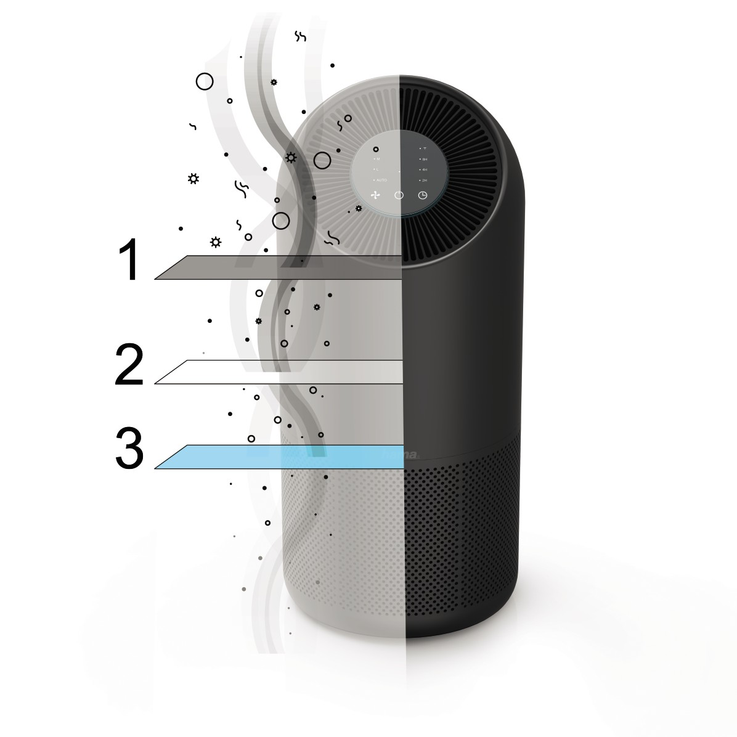three-stage filter system from Hama. The remarkable thing about this device: It can be controlled by voice command with Amazon’s Alexa or the Google Assistant and using the Hama Smart Home app. It is therefore very easy to operate – from anywhere and at all times. Whether you’re on your way home from work or sitting on the sofa. The filter system, too, is particularly sophisticated. The air purifier uses a three-stage filter system that includes a HEPA H13 filter, a pre-filter and an activated carbon filter, to filter pollen, pet hair, mites, viruses and bacteria out of the air. It removes 99.95 percent of particles (even the smallest) and smells; the purified air is noticeably hygienically fresh. The air purifier will manage a room size of 65 square metres at an air purification rate of 250 cubic metres per hour. The air sensor analyses the indoor air by itself and automatically sets the necessary fan speed for particle removal.
And all this is done entirely without a gateway, as the indoor air purifier establishes a WiFi direct connection to the router.

Item No. 00186437 Hama "Smart" Air Purifier, 3 x filter, Hepa, Filters Viruses, Pollen, Dust

