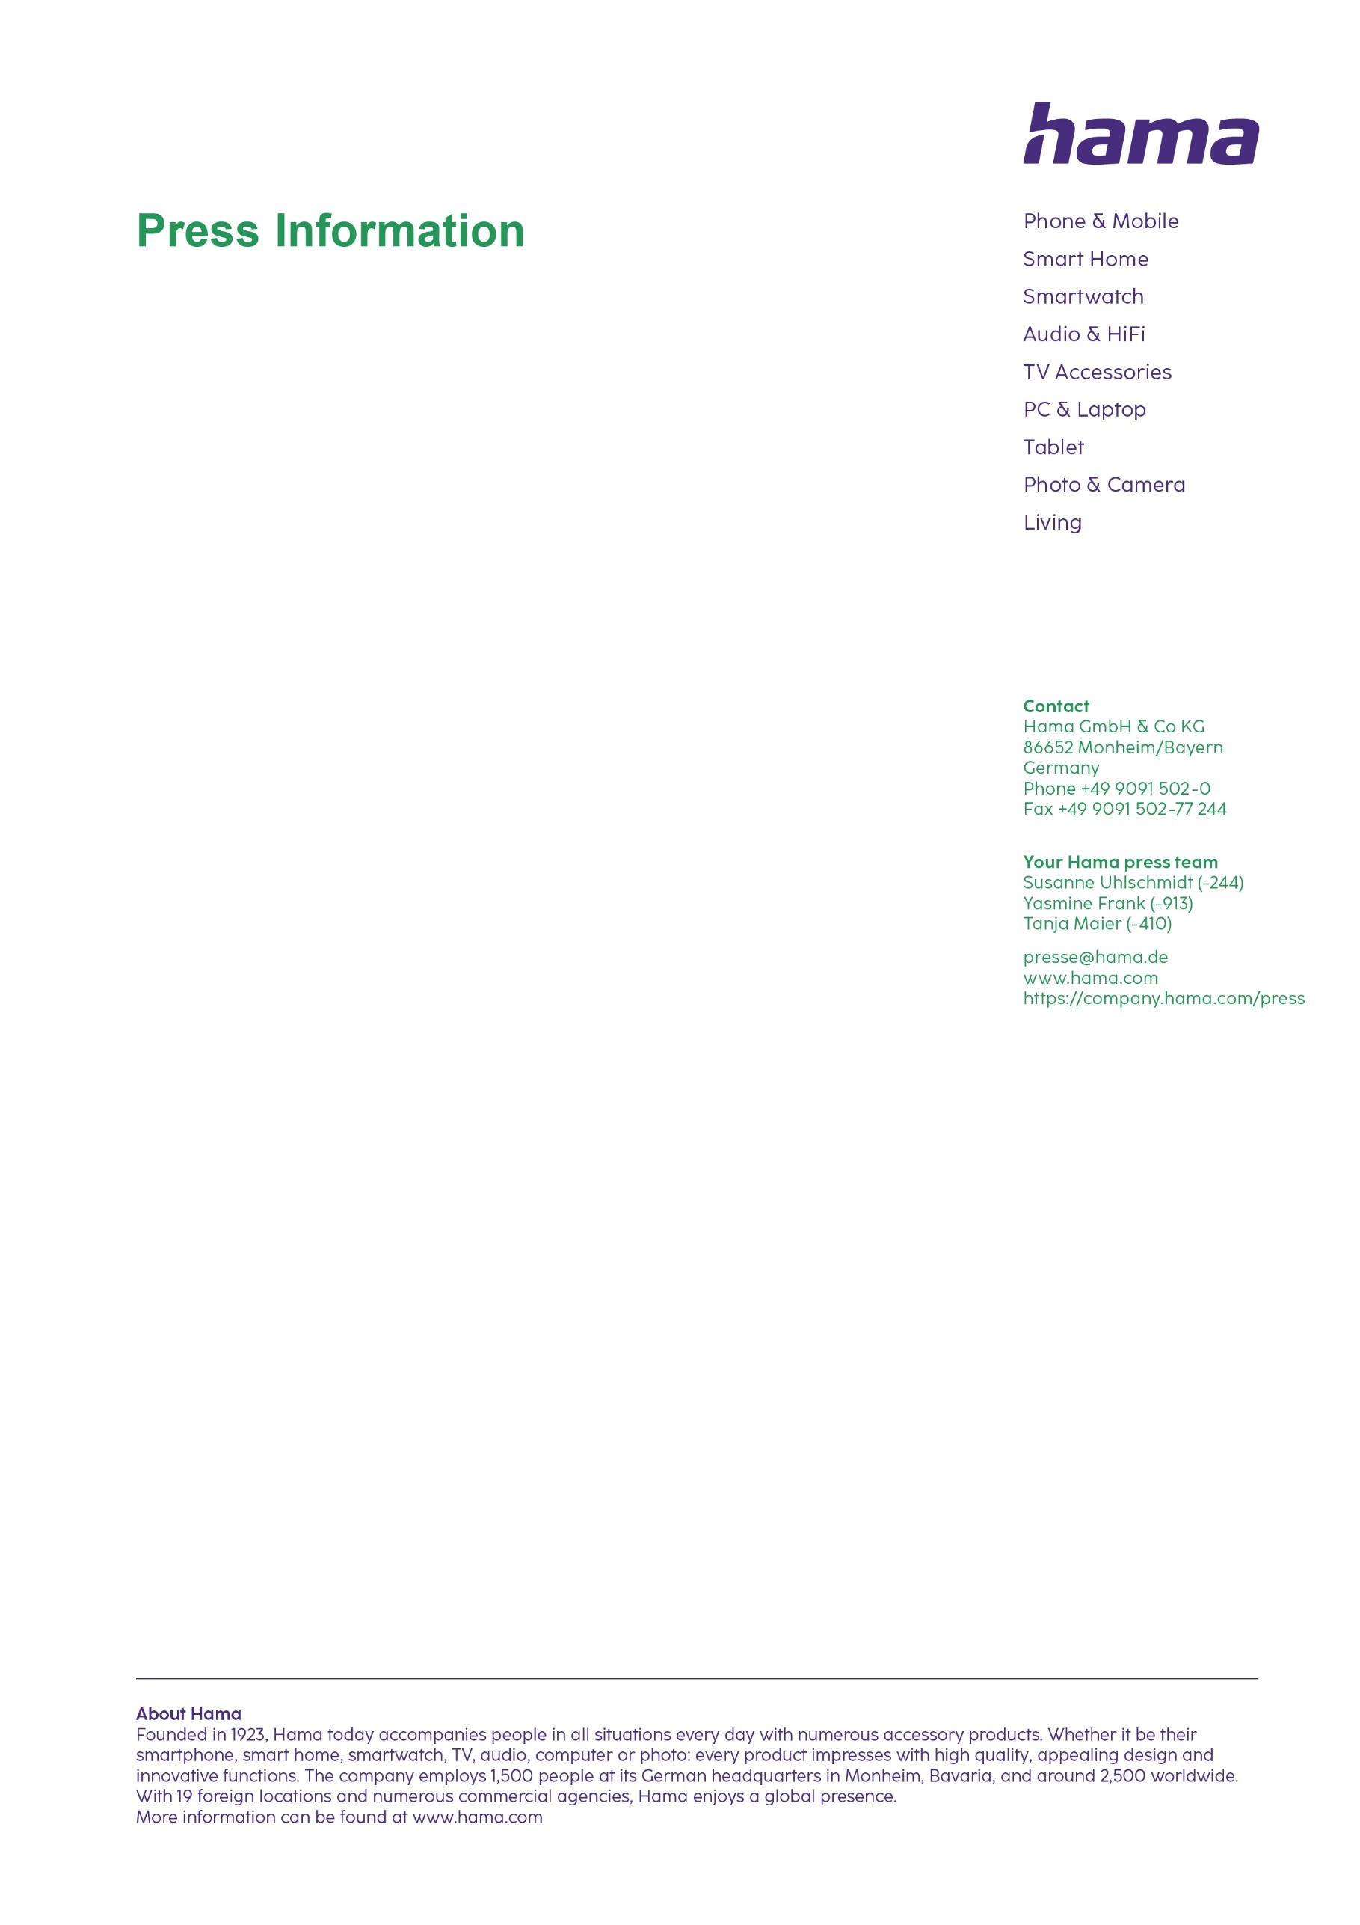
November 2024

Smart heating via underfloor heating

Smart underfloor heating thermostat

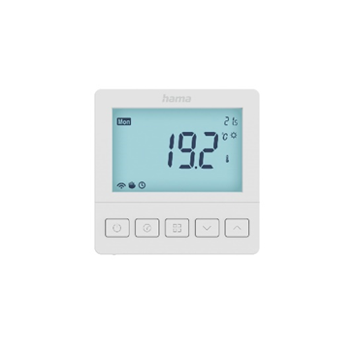
Smart heating can now also be done via underfloor heating - with the smart underfloor heating thermostat for flush installation from Hama. Simply replace the existing controller with the smart one. The room thermostat for hot water underfloor heating systems creates the perfect temperature day and night for feeling great and saving energy - a carefully thought out and efficient solution. The intelligent automated heating system independently calculates the ideal time to crank the heating up to achieve the desired temperature at the set time. So it’s ideal for intelligently upgrading an apartment or house. The system works with NO and NC actuators in hot-water-based underfloor heating systems, as well as hot water boilers. It allows a two-phase actuator and an external temperature to be connected. The large LC wall display is a hit, with five buttons and background lighting during operation. Since no hub is required, installation onto your own WiFi network is incredibly simple. Then you can conveniently control the heating via the app too, and most importantly program the heating time. For operation via a voice assistant, the thermostat works with Amazon Alexa, Google Assistant and Siri Shortcuts. All smart home products from other manufacturers that are compatible with Alexa and Google Assistant can also be linked. Other plus points include the Boost function, Away mode, automatic frost protection, child safety, open window detection and a number of other handy functions.

Item No. 00176629 Smart underfloor heating thermostat

Printable graphics data are available for download in our internet press club
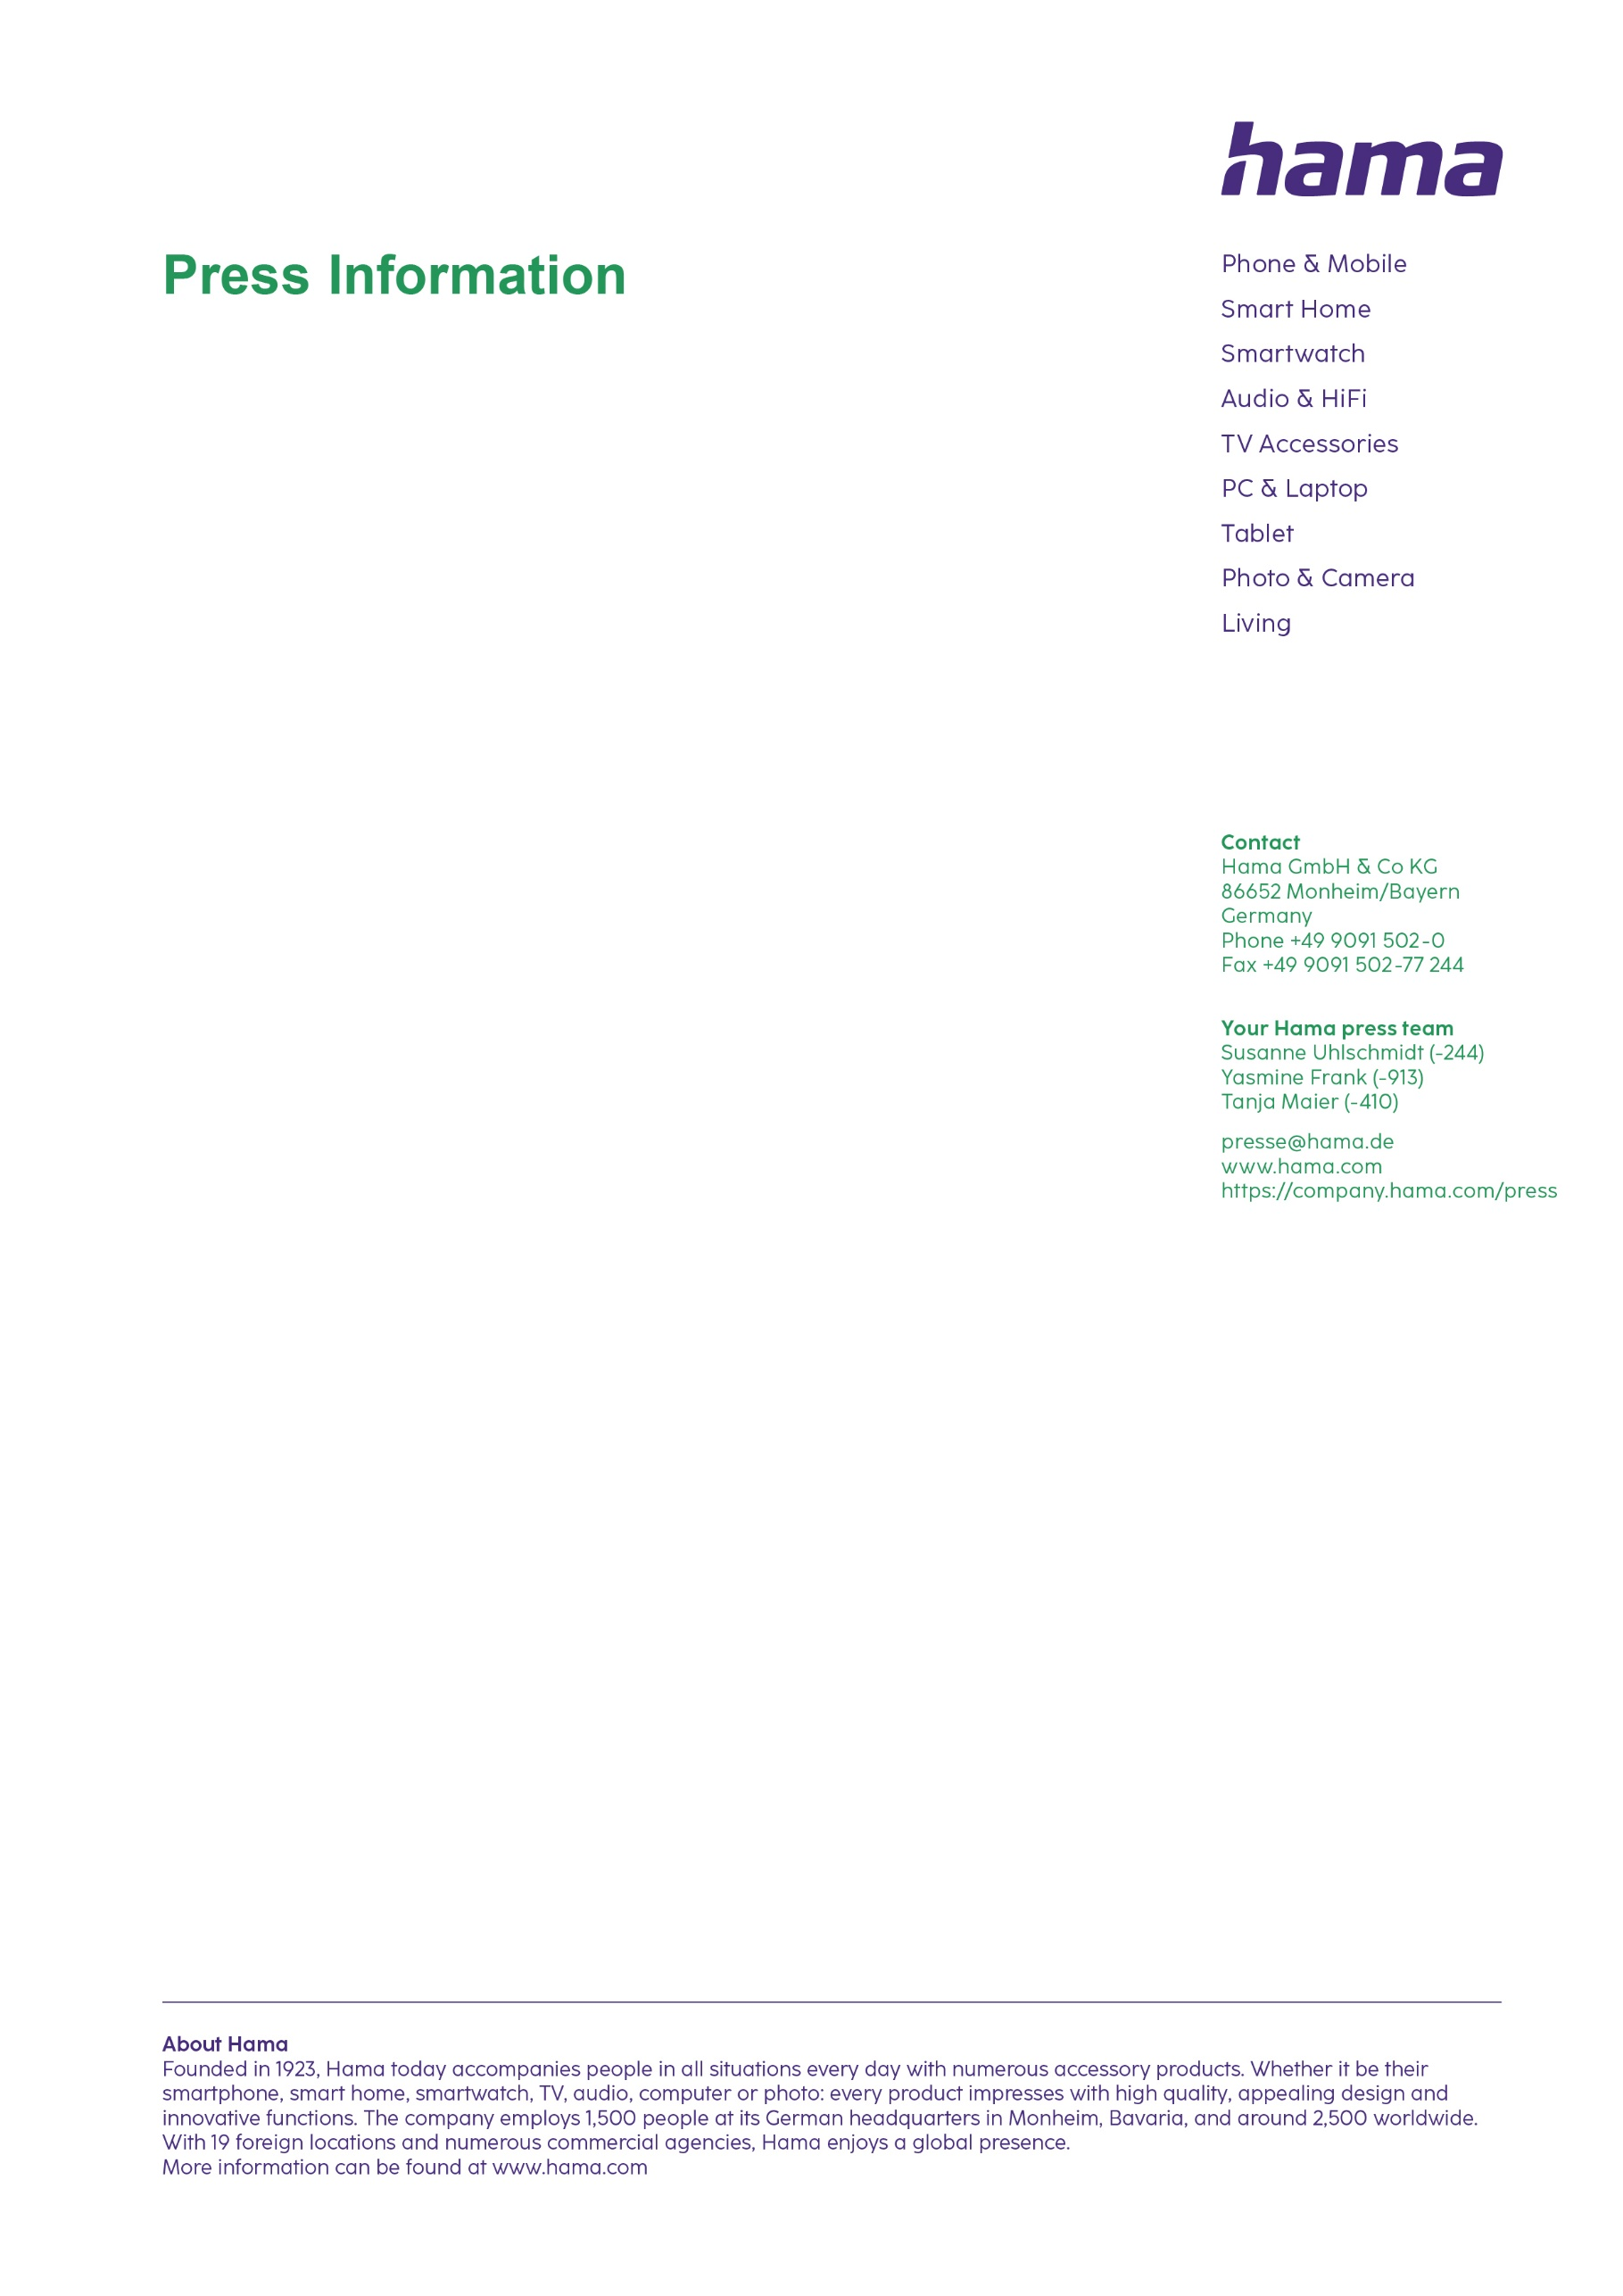
https://company.hama.com/press

