Intelligent heating
Smart heating control set
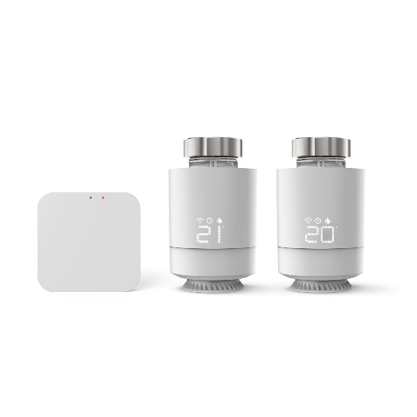
How lovely it would be to come back to a warm, cosy home without running the heating at full power all day? With smart heating control from Hama, this is now very simple. Just plug the base unit into the socket so that it can establish a connection to the home network, replace old thermostats with the smart versions, install the Hama Smart Home app, and you’re ready to go. Various programmes can now be selected and set. The heating control can be adjusted to personal times, and the temperature automatically raised to 21 degrees in the morning and lowered to 17 degrees at bedtime, for example. Spontaneous adjustments are possible at any time either by voice command, in the traditional way using the rotary control, or remotely using the app. The starter set comprises two smart radio thermostats plus the central control unit; any number of thermostats (item no. 176592) can be added. The right temperature in the entire home is thus achieved smartly in no time at all. The topic of sustainability has also been given some thought. For instance, a window contact (item no. 00176553) can be additionally installed. The heating system then switches off automatically when the window is opened. Even more energy can be saved with the Away mode, which is worth setting while you’re on holiday, for example. Here, the room is kept to a constant temperature of 16 degrees and complete cooling is prevented.

Item No. 176593 WLAN Heating Control, 2 x Smart Radiator Thermostats + Central Control

Item No. 00176592 Smart radiator thermostat for Hama WLAN heating control

Item No. 00176553 WiFi Door / Window Contact

