Two Bluetooth speakers for the IFA

Hama and Canton launch cooperation

Accessories specialist Hama and loudspeaker manufacturer Canton are launching a promising cooperation at this year's IFA in Berlin. Hama has expanded its audio range considerably in recent years and is taking the next step together with Canton, one of the best-known loudspeaker manufacturers, which has been developing in Germany since 1972 and has inspired generations of hi-fi enthusiasts ever since. The collaboration between the two renowned companies aims to provide music lovers with unparalleled sound quality. Under the motto "Pro Sound Experience with Canton", two Bluetooth speakers are coming onto the market that combine audiophile technology with the hip trend of mobility.

Glow Pro - Sound and light set the mood
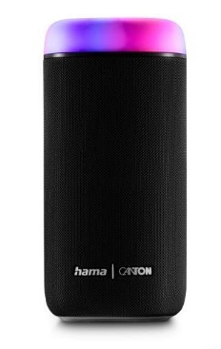
Music from your mobile phone, tablet or laptop: the Bluetooth speaker Glow Pro not only sets the mood with your favourite music, but also creates interesting light effects. 30 Watts of music power, the switchable Xtra Bass, five different light modes, a battery life of up to 12 hours, the charging option via USB-C within around three hours, the integrated hands-free system and the splash-proof housing make it the perfect party and patio companion. Depending on the environment and preferences, you can choose between the three modes Balance Sound, Power Sound and Bass Sound. If two speakers are connected via Bluetooth and placed anywhere in the room, the true wireless stereo function provides real stereo sound.

Mate Pro - Powerful sound to go
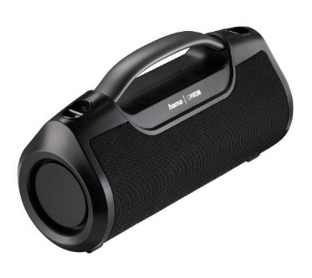
Whether it's a flat-sharing party or a garden party, with 60 Watt high-fidelity, a two-way low/mid and high-frequency driver and with an additional passive diaphragm for lowest frequencies per channel, the Mate Pro delivers powerful sound for up to twelve hours. At the touch of a button, you can switch between the three equaliser profiles Bass Sound, Power Sound and Balanced Sound. Highs and lows are thus better accentuated depending on the room situation. If you connect two speakers via Bluetooth, the true wireless stereo function provides real stereo sound. It also functions as a power pack that supplies your smartphone or tablet with power. The Mate Pro Bluetooth speaker is IPX6 waterjet-proof and therefore ideal for the sea or pool, but also for a good mood in the shower.

Glow Pro technical data
Maximum music performance: 30 W, Capacity: 2000 mAh, Voltage: 7.4 V
True wireless
Connection: 3.5 mm jack socket/USB-C socket/socket
Bluetooth version 5.0
Max. range: 10 m
Integrated Li-ion battery, average charging time: 3 hours, Maximum battery life: 12 hours
IP protection class: IPX4 (protection against spray)
Width x height x depth 9.6 cm x 19.5 cm x 9.6 cm
Weight: 700g

Mate Pro technical data
Maximum music performance: 60 W, Capacity: 36000 mAh, Voltage: 7.4 V
True wireless
Connection: 3.5 mm jack socket/USB-C socket/socket/USB Type A socket
Bluetooth version: 5.0
Max. range: 10 m
Integrated Li-ion battery, average charging time: 3 hours, Maximum battery life: 12 hours
IP protection class: IPX6 (protection against heavy continuous rain)
Width x height x depth 31 cm x 15.2 cm x 11.8 cm
Weight: 2550 g

Item No. 188230 Bluetooth speaker Glow Pro
Item No. 188219 Bluetooth speaker Mate Pro

About Canton
Canton is one of the largest German hi-fi loudspeaker manufacturers with its own production facilities in the heart of the Taunus region. The medium-sized company has been managed by the owner family since its foundation in 1972 and comprises a product portfolio for high-end loudspeakers, Smart Wireless music systems, soundbars, as well as built-in solutions for walls and ceilings. More info at www.canton.de

About Hama
Founded in 1923, Hama today accompanies people in all situations every day with around 18,000 accessory products. Whether it be their smartphone, smart home, smartwatch, TV, audio, computer or photo: every product impresses with high quality, appealing design and innovative functions. The company employs 1,500 people at its German headquarters in Monheim, Bavaria, and around 2,500 worldwide. With 19 foreign locations and numerous commercial agencies, Hama enjoys a global presence.
More information can be found at www.hama.com

