Press Information
Phone & Mobile
Smart Home
Smart watch
Audio & HiFi
TV Accessories
PC & Laptop
Tablet
Photo & Camera
Living

Contact
Hama GmbH & Co KG
86653 Monheim/Bavaria
Germany
Phone +49 9091 502-0

Your Hama press team
Susanne Uhlschmidt (-244)
Yasmine Frank (-913)
Tanja Maier (-410)
presse@hama.de
https://company.hama.com/press

April 2025

Open and close via app or voice command

Smart garage door opener

Very few garage doors are still operated manually these days; they are usually closed and opened electronically by remote control or switch. The smart garage door opener from Hama provides even more convenience and security and makes everyday life easier in many situations.

To operate the garage door in future via smartphone app or voice command, the small garage door opener is connected to the existing door operator and supplied with power via USB. It is easily compatible with a wide range of manufacturer variants and can therefore be used universally. Without a gateway and therefore without additional costs, it establishes a direct WiFi connection to the router and is quickly ready for use.

More options than you think
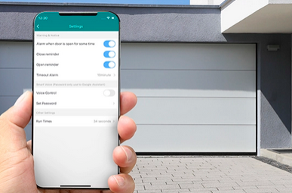
The smart garage door opener from Hama is not just about convenient entry and exit. If, for example, the parcel delivery service has announced its arrival, you can grant it access remotely and then lock everything again conveniently and securely. Once you have finally managed to stow the shopping in the house, you can close the door without setting foot outside the front door again using an app or by giving Alexa, Siri or Google a voice command. Automated schedules can be just as useful as the use of geofencing. The door opens simply by the mobile phone approaching it. Or you can extend its use with other smart products, whereby automatically switches on the lights or closes the garage, for example, if the integrated weather station detects sub-zero temperatures, which could damage the plants that have been set to overwinter. The possibilities are endless and the great thing about it is that you always know exactly what you're doing via the app, whether you're at home on the sofa or on holiday at the beach. The anxious question "Have I actually closed the garage door?" is now a thing of the past.
Phone & Mobile
Smart Home
Smart watch
Audio & HiFi
TV Accessories
PC & Laptop
Tablet
Photo & Camera
Living

Contact
Hama GmbH & Co KG
86653 Monheim/Bavaria
Germany
Phone +49 9091 502-0

Your Hama press team
Susanne Uhlschmidt (-244)
Yasmine Frank (-913)
Tanja Maier (-410)
presse@hama.de
https://company.hama.com/press

Item No. 00176680 Smart Garage Opener

Printable graphics data is available for download in our internet press club
https://company.hama.com/press

Phone & Mobile
Smart Home
Smart watch
Audio & HiFi
TV Accessories
PC & Laptop
Tablet
Photo & Camera
Living

Contact
Hama GmbH & Co KG
86653 Monheim/Bavaria
Germany
Phone +49 9091 502-0

Your Hama press team
Susanne Uhlschmidt (-244)
Yasmine Frank (-913)
Tanja Maier (-410)
presse@hama.de
https://company.hama.com/press

