Coffee is a perennial topic in retail

Xavax Barista - Accessories for coffee

Coffee - for some a necessary elixir of life, for others a stylish indulgence and for many a combination of both. Coffee is also a perennial topic in retail, and one with growth forecasts to boot. Under its own brand Xavax, Hama presents a concept where the name says it all. Xavax Barista stands for coffee accessories that generate profitable additional business alongside the preparation machines.

Continuous demand
Xavax Barista offers the right accessories, whether for a filter machine, fully automatic machine, pad, capsule or filter model. Timeless and stylish in matt black and stainless steel, the extensive product range is perfectly coordinated: measuring spoons, permanent filters and pads, milk frothers and jugs, tamper sets, tapping boxes, espresso makers and storage containers are all part of the extensive range. In addition, consumables such as mill cleaners, degreasing tablets or silicone grease ensure continuous demand.

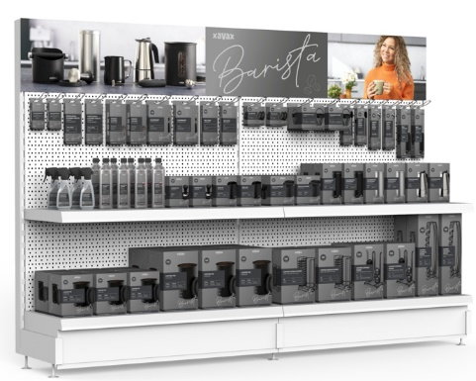
Attention at the PoS
On the sales floor, Xavax Barista not only catches the eye with product ideas, but also with the packaging design. Based on the stylish ambience in which coffee machines and especially trendy filter machines are usually displayed, the Xavax Barista range also scores with a PoS appearance in an elegant, restrained colour scheme. The plastic-free, FSC-certified packaging with the concise Barista lettering and large product images also focuses on self-service capability. It is reduced and tidy, but at the same time informative and thus the ideal sales support. This is not only effective for sales walls, but also for smaller individual displays, which are particularly suitable for space-saving but effective secondary placements.
About Hama
Founded in 1923, Hama today accompanies people in all situations every day with around 18,000 accessory products. Whether it be their smartphone, smart home, smartwatch, TV, audio, computer or photo: every product impresses with high quality, appealing design and innovative functions. The company employs 1,500 people at its German headquarters in Monheim, Bavaria, and around 2,500 worldwide. With 19 foreign locations and numerous commercial agencies, Hama enjoys a global presence.
More information can be found at www.hama.com

