Wireless power for all Apple Watches

Apple Watch charger

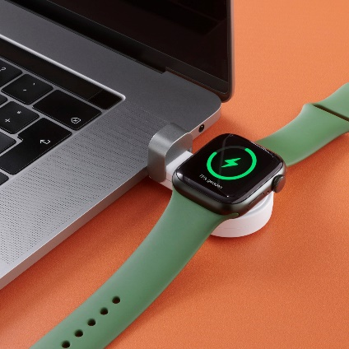
Place - Charge - Done. Magnetic induction charging technology, already familiar from smartphones, is now making its way to Hama with the wireless Apple Watch charger for the smart watches from the well-known technology company. The built-in magnet ensures exact positioning of the integrated coils, the charging process starts automatically after the smart watch is placed on it and stops when it is lifted. Especially practical: the charger works with all generations of Apple Watches.
Overcharge, overvoltage and short-circuit protection as well as foreign object detection guarantee safe and intelligent charging.
Another clever detail is the protective cap that protects the USB-C port from dirt and mechanical stress during transport. This allows the charger to be quickly and easily connected to the power pack, laptop or a socket adapter. These features are rounded off by the pleasant soft-touch surface for a comfortable feel and secure positioning of the smart watch. The wireless Apple Watch charger is available in stores in white or black and white.

Item No. 201698 Apple Watch Charger f Wireless Charging, Magnetic USB-C Charging Station, black
Item No. 201699 Apple Watch Charger f Wireless Charging, Magnetic USB-C Charging Station, white

About Hama
Founded in 1923, Hama today accompanies people in all situations every day with around 18,000 accessory products. Whether it be their smartphone, smart home, smartwatch, TV, audio, computer or photo: every product impresses with high quality, appealing design and innovative functions. The company employs 1,500 people at its German headquarters in Monheim, Bavaria, and around 2,500 worldwide. With 19 foreign locations and numerous commercial agencies, Hama enjoys a global presence.
More information can be found at www.hama.com

