Press Information
Phone & Mobile
Smart Home
Smartwatch
Audio & HiFi
TV Accessories
PC & Laptop
Tablet
Photo & Camera
Living

Contact
Hama GmbH & Co KG
86653 Monheim/Bayern
Germany
Phone +49 9091 502-0

Your Hama press team
Susanne Uhlschmidt (-244)
Yasmine Frank (-913)
Tanja Maier (-410)
presse@hama.de
https://company.hama.com/press

September 2025

Hama wins IFA Innovation Award

The winners of the IFA Innovation Awards were announced on the first day of the IFA trade fair. Accessories specialist Hama is one of them.

Winner in the "Best in Audio" category
The AI-assisted Passion Clarity AI headphones, which Hama is launching on the market in collaboration with the Munich-based company Bragi, won over the high-calibre jury. The international panel, consisting of recognised tech journalists and industry experts, named it the winner in the "Best in Audio" category.

Passion Clarity AI impresses with its technical features
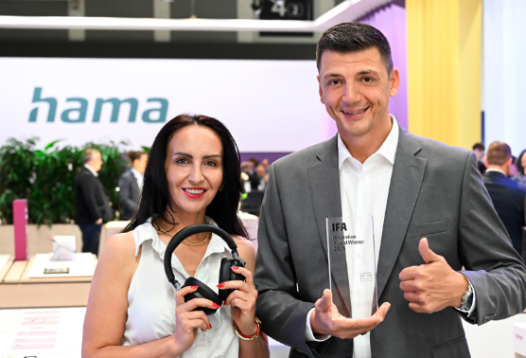
The Bragi Sound app extends the headphones far beyond pure music enjoyment. The use of artificial intelligence, for example, makes it possible to adapt the sound to individual user behaviour. It also offers access to innovative features such as a live translation function and integrated chat AI. The powerful-sounding Passion Clarity AI precisely suppresses background noise and impresses with many other innovative features. The award-winning headphones will be delivered in the course of 2026 under the item number 00221819.
Product Manager Nadja Miller and Managing Director Christian Sokcevic present the IFA Innovation Award

Printable graphics data are available for download in our internet press club
https://company.hama.com/press

