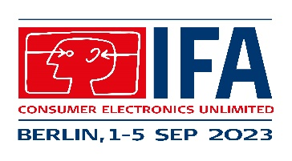

Hama at the IFA in Berlin

IFA highlights at the Hama stand

The IFA in Berlin, which opens its doors on 1 September, is the most important consumer electronics trade fair and is just around the corner. Accessories specialist Hama is offering a small preview of what dealers can expect at Stand 101 in Hall 4.2.

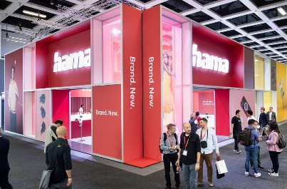
At the 1200-square-metre IFA stand, Hama will be presenting innovative product highlights from its extensive and varied portfolio, showcasing trend themes and ranges with potential for strong sales, and providing information on packaging concepts which, in addition to sustainability aspects, also entail optimum presentation at the PoS. Numerous interesting partner brands will be present at the Hama stand with their own areas. Hama works closely with them, thus expanding the product range and offering retailers interesting alternatives with added value.

The first Matter-enabled product from Hama
The big wait is over. Hama, a member of the Connectivity Standard Alliance, is launching its first Matter-enabled product, a compact WLAN socket, which will be available nationwide as early as October. Further products that support the new, cross-manufacturer smart home standard Matter are not only in the planning stage, but will already be presented live at IFA. For example, various light sources are coming onto the market in time for the upcoming dark season.

New generation smart watches
Hama is launching new smart watches just in time for strong sales in the run-up to Christmas. In addition to Alexa voice control, a barometric altimeter, compass function and up to 110 sports, the new models offer numerous clever functions.

Hama and Canton - a shared sound
Audio continues to be an area of immense end-user interest in consumer electronics. Canton, one of the largest German Hi-Fi loudspeaker manufacturers, and Hama are working together and presenting the first joint, powerful-sound products at the IFA.

D3O - smartphone cases for extreme protection
New, shock-absorbing mobile phone cases made of the innovative material from D3O® guarantee extreme shock, impact and drop protection. The unique material always remains transparent thanks to anti-yellowing technology, which is another selling point that really raises interest.

Future in TV - the TV sector is being repositioned
In the TV sector, everything is getting bigger, flatter, heavier and more flexible. Hama will be showcasing solutions across all segments with wall mounts, remote controls, connection cables and many other products. Everything from a single source and in a new, clear look for perfect sales support at the PoS.

Xavax Barista - Accessories for coffee enjoyment
Hama's own brand Xavax continues to grow. Whether for fully automatic coffee machines, filter or capsule machines - Xavax Barista has the right accessories for every coffee lover. Timeless and stylish, the products speak for themselves and generate demand.

About Hama
Founded in 1923, Hama today accompanies people in all situations every day with around 18,000 accessory products. Whether it be their smartphone, smart home, smartwatch, TV, audio, computer or photo: every product impresses with high quality, appealing design and innovative functions. The company employs 1,500 people at its German headquarters in Monheim, Bavaria, and around 2,500 worldwide. With 19 foreign locations and numerous commercial agencies, Hama enjoys a global presence.
More information can be found at www.hama.com

