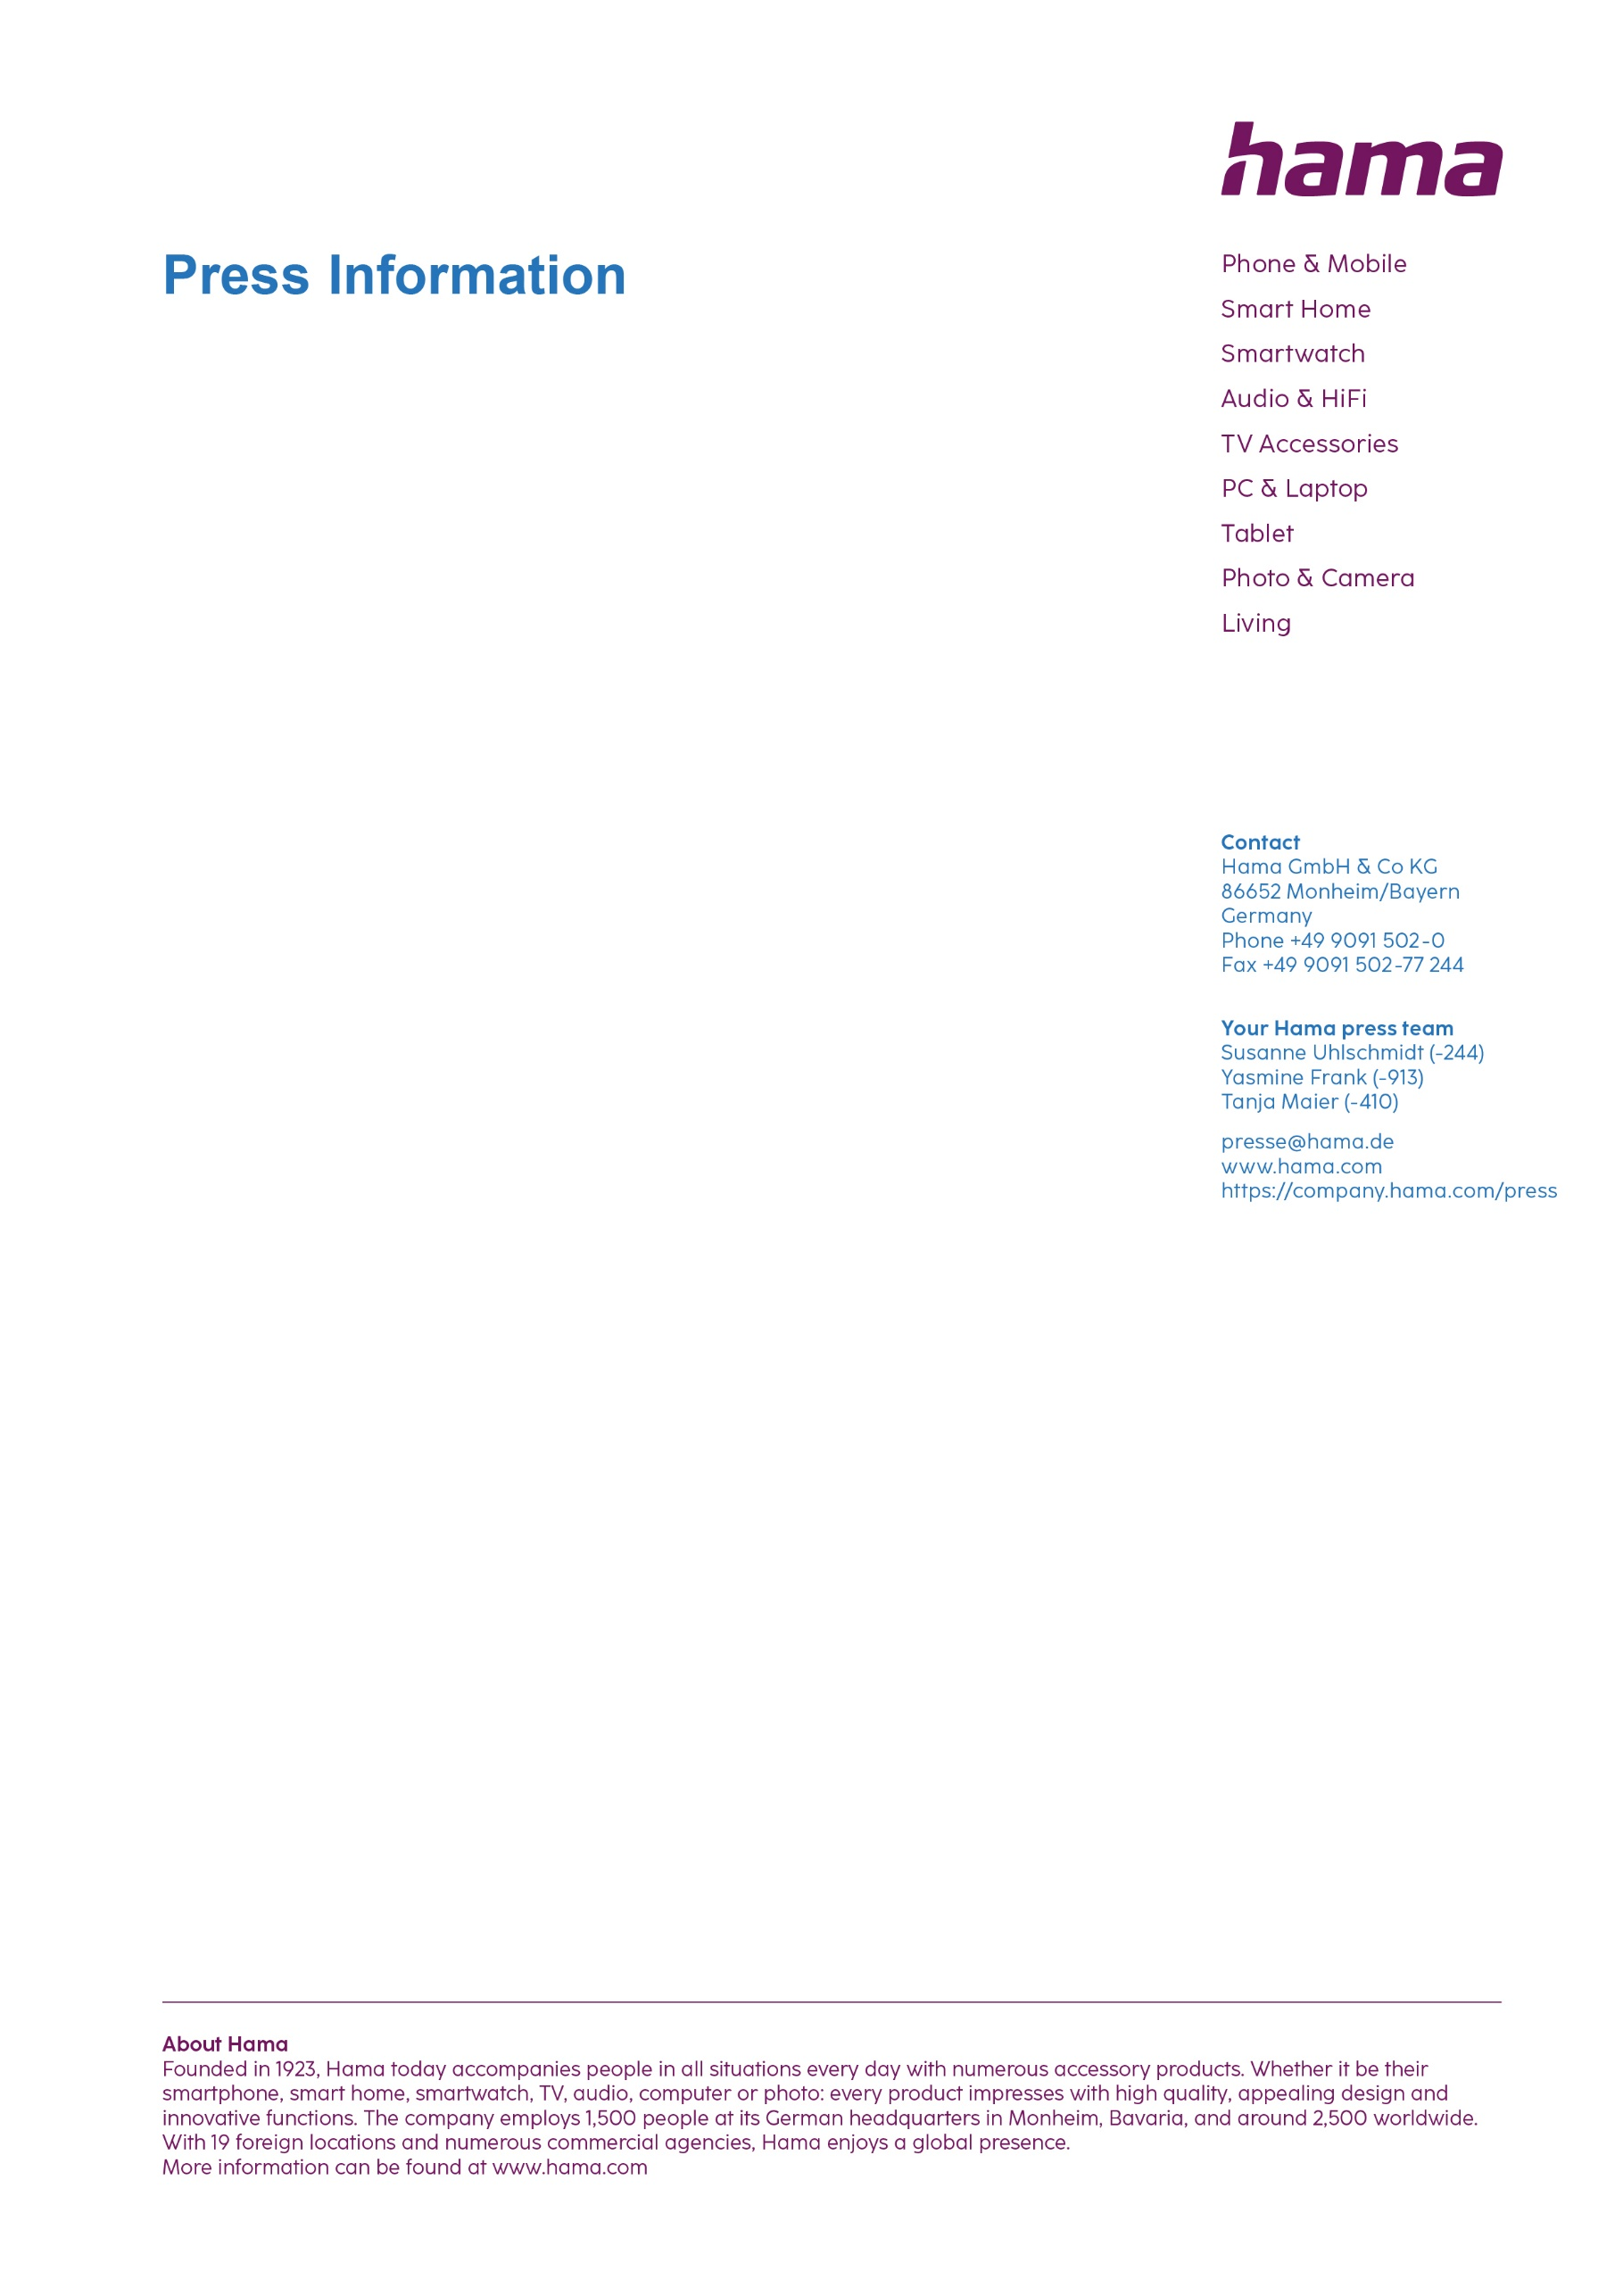
January 2025

Bags and cases from the Hama "Extreme Protect" series

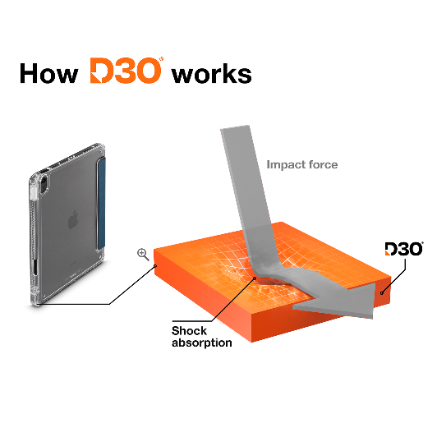
Notebook and tablet in shockproof packaging
Safety is the top priority with the Hama "Extreme Protect" bag series. In collaboration with D3O, the global market leader for impact protection, the company has now also created cases and a backpack for notebooks and tablets which offer the best impact, drop and scratch protection thanks to extremely hard-wearing material.

The patented D3O material, originally known from motorbike protective clothing, absorbs the impact energy, dissipates it and thus offers highly effective impact protection. For good reason, Hama is now also equipping cases for notebooks, mobile phones and tablets with this technology. The "Extreme Protect" series is commercially available for a wide range of appliance types and sizes.

Item No. 227050-51 Laptop Bag Extreme Protect
Item No. 227052 Laptop Backbag Extreme Protect
Item No. 227055-56 Laptop-Sleeve Extreme Protect
Item No. 227032-35 Tablet Case Extreme Protect iPad Air 13
Item No. 227028-31 Tablet Case Extreme Protect iPad Air 11
Item No. 227024-27 Tablet Case Extreme Protect iPad Pro 13
Item No. 227020-23 Tablet Case Extreme Protect iPad Pro 11
Item No. 227016-19 Tablet Case Extreme Protect Galaxy Tab A9+ 11

Printable graphics data are available for download in our internet press club
https://company.hama.com/press

