

‘Connect2Office Basic’ USB-C docking station

A large selection fitted into a small space

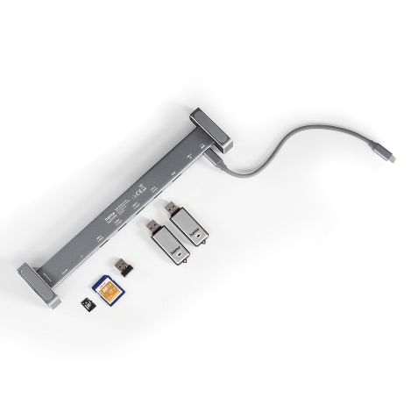
Nine ports, all fitted neatly into a slim hub that resembles a crossbar. The ‘Connect2Office Basic’ USB-C docking station from Hama provides a variety of slots, which a user can add to their ultraflat laptop, for instance. Yet it measures just 28.2 x 3.3 x 6 centimetres and will easily fit into the front compartment of a laptop bag. Its removable feet are rubberised for a stable standing position and can be completely removed for travel.
The nine inputs are: one USB-C power, one HDMI and one LAN connection; four USB-A ports; one SD and one microSD card reader. The hub boasts an HDMI input with Ultra-HD technology and an Ethernet connection with a data transfer rate of up to 1 Gbit/s. The spacing between sockets is wide enough to allow easy connection and disconnection of plugs and cards. The ‘Connect2Office Basic’ docking station gets its power via USB. The high-quality, robust aluminium housing looks elegant and rounds off the features of the hub.

Item No. 200103 "Connect2Office Basic" USB-C Docking Station

About Hama
Hama was founded in 1923 and with approximately 18,000 products the company is nowadays one of the leading accessory suppliers in the fields of multimedia, photo, consumer electronics and telecommunications. 1500 people work at the German headquarters in Monheim, Bavaria, about 2500 people are employed all around the world. With 19 sites, numerous sales agencies and its own production facilities Hama is represented all over the world with its high-quality products.
More information at www.hama.com

