Press Information
Phone & Mobile
Smart Home
Smartwatch
Audio & HiFi
TV Accessories
PC & Laptop
Tablet
Photo & Camera
Living

Contact
Hama GmbH & Co KG
86653 Monheim/Bayern
Germany
Phone +49 9091 502-0

Your Hama press team
Susanne Uhlschmidt (-244)
Yasmine Frank (-913)
Tanja Maier (-410)
presse@hama.de
https://company.hama.com/press

Hall 4.2, Booth no. 145



Hama provides IFA insights

The IFA, the largest international trade fair for the industry, takes place in Berlin at the beginning of September. Accessories specialist Hama will be represented with a 1200-square-metre stand in Hall 4.2, which as usual is designed as a specialist trade centre. There will be one noticeable change: Hama is opening up visually and giving all visitors an insight into the world of consumer electronics

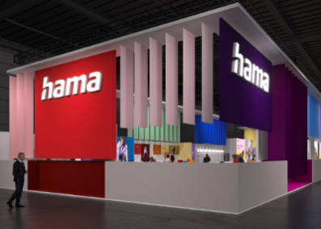
Once again this year, an impressive range and variety of products will be presented at the Hama stand. A glance at the list of products and topics confirms this. Qi2-enabled chargers, new Made-in-Germany mobile phone cases, customised display protection, cables made from recycled PVC, children's watches, the implementation of the USB-C obligation in the notebook sector and illuminated POS presentations that not only showcase products but also attract attention in general are just a few examples.

Sound booth and partner cubes
In addition to Canton loudspeakers, new interesting AI headphones will be demonstrated live in a large sound booth at. The partner brands Beyerdynamic, Rapoo, Sandisk, Signify and Western Digital will also be presented in their own cubes and the gaming own brand uRage will also have its own area.

