Protection and power for new smartphones from Samsung

Hama accessories complement Galaxy S24 models

Delivery of the new Galaxy S24 models from Samsung began on January 24th. Hama already has the perfect matching accessories for the three smartphone models.

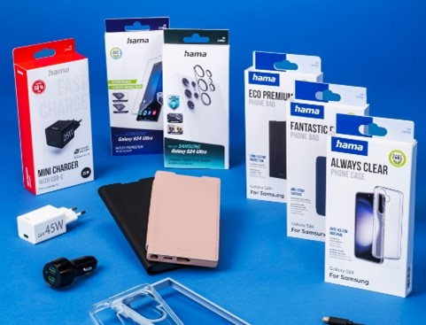
The new Samsung flagship mobiles, the Galaxy S24, S24 Plus and S24 Ultra were unveiled for the first time on 17 January, and deliveries began on 24 January. Hama is already able to equip the new Galaxy models with suitable accessories. Sleeves, bags, screen protectors and covers for the camera lenses on the back, plus chargers delivering up to 45 Watts for the S24 Plus and S24 Ultra models, ensure perfect protection and the perfect boost of power right from the start.

About Hama
Founded in 1923, Hama today accompanies people in all situations every day with around 18,000 accessory products. Whether it be their smartphone, smart home, smartwatch, TV, audio, computer or photo: every product impresses with high quality, appealing design and innovative functions. The company employs 1,500 people at its German headquarters in Monheim, Bavaria, and around 2,500 worldwide. With 19 foreign locations and numerous commercial agencies, Hama enjoys a global presence.
More information can be found at www.hama.com

