Always to hand: mobile phone, cards and money

Card case for iPhones with MagSafe

Mobile phone, a bit of cash and maybe your driver's licence. You do have to take quite along with you when you leave the house. If you have an iPhone with MagSafe function, you can simply dock the magnetic card case from Hama onto the back of the smartphone and you're ready to go.

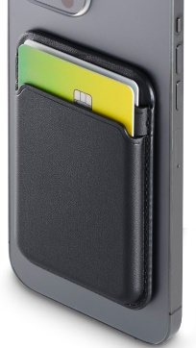
If you have an iPhone 12 or later with MagSafe function, you'll be familiar with the advantages of the integrated magnet. The phone can be quickly, easily and very securely attached to mounts or charging stations. The slimline case made from black leather from Hama works in exactly the same way. Simply stash cards and money in the two compartments, dock the case to the phone and off you go.

The card case with elegantly structured surface attaches securely to the
smartphone and also to MagSafe-compatible bags, of course does not cover up the mobile phone camera, is quickly removed and also allows quick access to cards and more thanks to the easy-slide function.

Item No. 196799 Card Case for Apple iPhone 12/13/14/15

About Hama
Founded in 1923, Hama today accompanies people in all situations every day with around 18,000 accessory products. Whether it be their smartphone, smart home, smartwatch, TV, audio, computer or photo: every product impresses with high quality, appealing design and innovative functions. The company employs 1,500 people at its German headquarters in Monheim, Bavaria, and around 2,500 worldwide. With 19 foreign locations and numerous commercial agencies, Hama enjoys a global presence.
More information can be found at www.hama.com

