For long gaming sessions

uRage ‘Guardian 300’ gaming chair

Video games are more popular than ever. According to surveys, more and more users are spending up to seven hours a week more on their devices than in 2020.
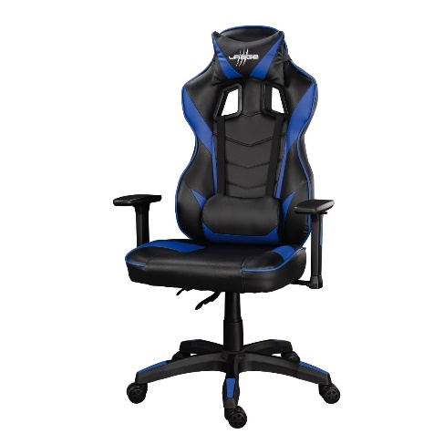
A comfortable chair is important, especially for long gaming sessions, which is why uRage has developed the ‘Guardian 300’. Its padded neck and lumbar cushions allow gamers to sit comfortably for several hours. The chair is continuously height adjustable from 119 to 129 centimetres and thus accommodates most age groups; the backrest adjusts to individual ergonomics and preferences. An inclination angle of up to 120 degrees ensures a relaxed sitting position during immersive games. Thanks to 3D armrests that can be flexibly adjusted in all directions, the ‘Guardian 300’ offers ergonomic positioning of the support surface when using peripheral devices. Besides these visual details, the chair has a sturdy nylon star base with 60-millimetre hard floor castors that glide gently over parquet or laminate flooring. The built-in gas spring boasts a maximum load capacity of 150 kilogrammes.

Item No. 00096020 uRage ‘Guardian 300’ gaming chair

