

Hama smart watch 8900

Sporty with microphone and loudspeaker

The Hama "8900" smart watch is a latest-generation smart watch that is being unveiled at the up-coming IFA. Available in black, silver-beige or gold-beige and with a high-quality aluminium housing, it satisfies many tastes from the outside alone and scores highly when it comes to the technical details too.

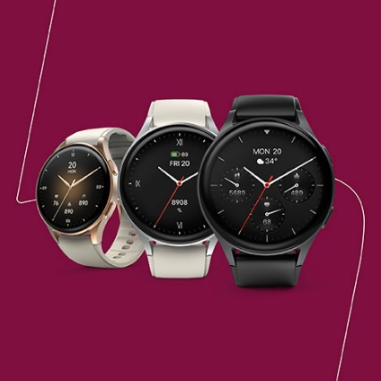
The first thing to notice is the large AMOLED display with the always-on function, through which all manner of features can be controlled and monitored. Thanks to the integrated microphone and loudspeaker, the most exciting highlights of this generation of smart watches include telephony via Bluetooth and Alexa voice control. It allows you to accept incoming calls, check the weather or control Smart Home products. This new generation of smart watches is also placing the focus squarely on sport and movement. This means that the number of types of sport available to choose from has been increased to 110, the watch now features GPS and there is also a built-in altimeter and compass.
Of course, the series of new smart watches, all of which feature the IP68 protection class, also features the classics such as blood oxygen and pulse measurement, a step counter, calories burned, music control and many more.
Item No. 178611 Smart Watch 8900, black
Item No. 178612 Smart Watch 8900, silver-beige
Item No. 178613 Smart Watch 8900, gold-beige

About Hama
Founded in 1923, Hama today accompanies people in all situations every day with around 18,000 accessory products. Whether it be their smartphone, smart home, smartwatch, TV, audio, computer or photo: every product impresses with high quality, appealing design and innovative functions. The company employs 1,500 people at its German headquarters in Monheim, Bavaria, and around 2,500 worldwide. With 19 foreign locations and numerous commercial agencies, Hama enjoys a global presence. More information can be found at www.hama.com

