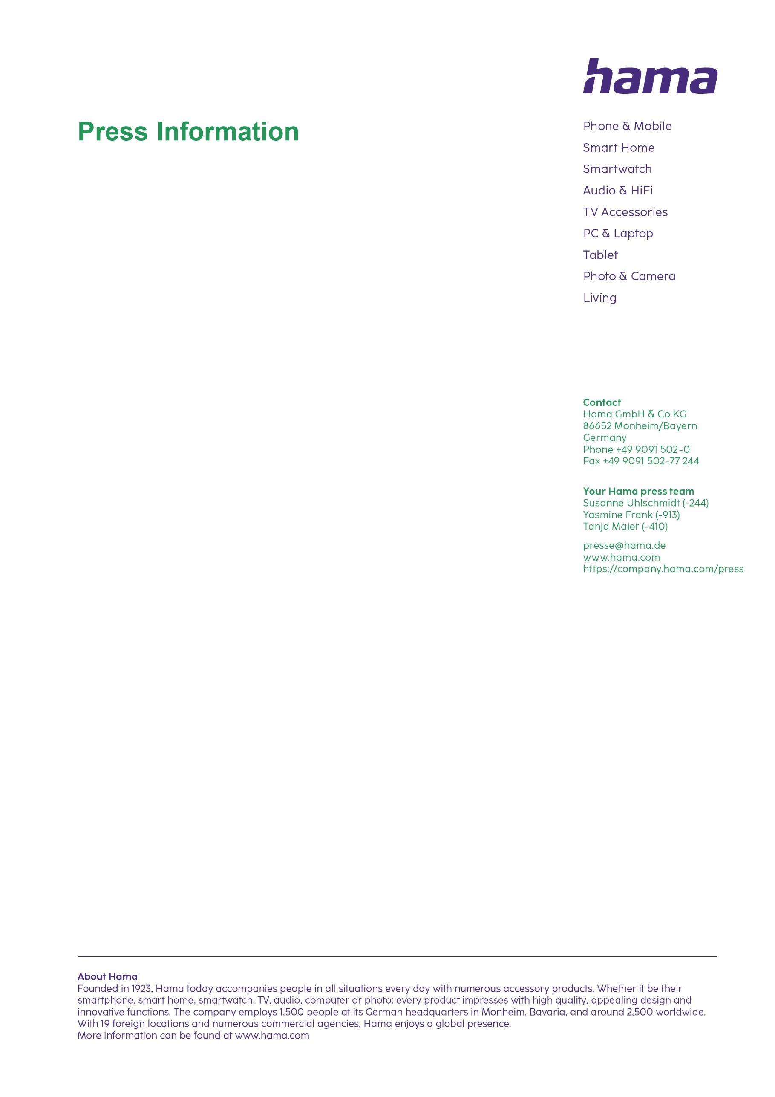
December 2024

Open - Pair - Type

Foldable mini keyboard with Bluetooth

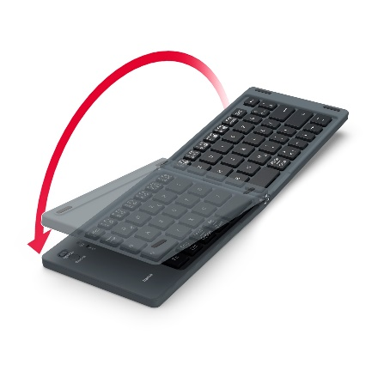
Quickly write an e-mail on the bus on the way to uni, transfer the results of your library research to a tablet or for space-saving transport between the home office and office: the “Travel 450” foldable Bluetooth mini keyboard with magnetic closure from Hama is always to hand, impressing with its ultra-slim design and working with all Bluetooth-enabled devices. The 65 per cent keyboard without number block offers laser-printed keys with high wear resistance and a reliable range of ten metres. It’s super-easy to use: simply pair and get typing. To ensure that your freedom is preserved for a long as possible, there is a separate On and Off switch, as well as standby mode that kicks in after ten minutes of inactivity. However, if a boost of energy is needed, the 80-cm-long charging cable allows you to carry on working while charging.

Item No. 125136 Hama “Travel 450” Bluetooth Mini Keyboard, Foldable

Printable graphics data are available for download in our internet press club
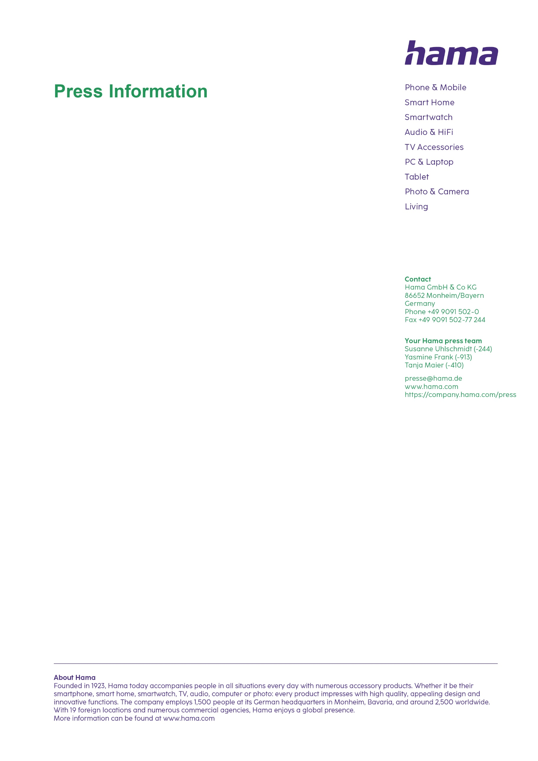
https://company.hama.com/press

