

Smart watchdogs for indoors and outdoors

Three new surveillance cameras from Hama

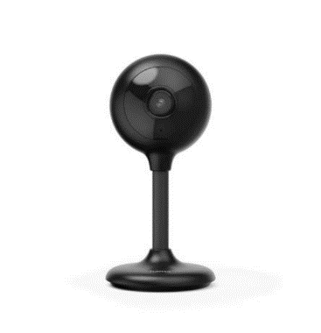
Whether you're worried about your baby or afraid of dodgy characters in your own garden, surveillance cameras now help to give you peace of mind in many areas. Hama is presenting three new models that meet different requirements and can also be controlled smartly from a mobile phone. You can’t get more convenient than this.
176651

Elegant exterior - smart interior

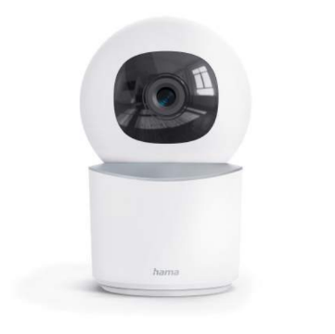
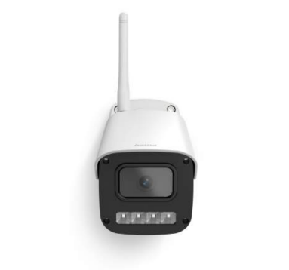
All three surveillance cameras send the recordings in full HD with 1080p via Wi-Fi to your smartphone using the app. Recording takes place after a movement is detected. Fully automatic and even in the dark thanks to infrared night vision. If desired, the sequences can also be saved on a micro SD card in the cameras. The voice control allows elegant and convenient operation via the display of Amazon Echo, for example, and communication with the person in front of the camera is also easily possible thanks to the 2-way audio system. Also of interest: The movable indoor camera (176652) can be panned and tilted using the app and also recognises only human movements. Perfect as a monitoring aid in prioritised indoor areas. The outdoor camera for façade mounting (176653), on the other hand, is also dust and splash-proof pursuant to IP54.
176652
176653
Item No. 176651 Smart Surveillance Camera;
Item No. 176652 Smart Surveillance Camera, Swivel
Item No. 176653 Smart Surveillance Camera, for Outdoors

About Hama
Founded in 1923, Hama today accompanies people in all situations every day with around 18,000 accessory products. Whether it be their smartphone, smart home, smartwatch, TV, audio, computer or photo: every product impresses with high quality, appealing design and innovative functions. The company employs 1,500 people at its German headquarters in Monheim, Bavaria, and around 2,500 worldwide. With 19 foreign locations and numerous commercial agencies, Hama enjoys a global presence.
More information can be found at www.hama.com

