Intelligent power strip with four individually controllable sockets

Quadruple WLAN socket strip from Hama

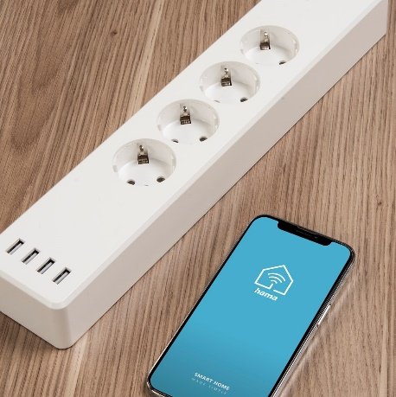
The floor lamp in the corner, the TV on the wall, the soundbar on the chest of drawers and the receiver on the shelf - four different devices that can be controlled smartly either individually or together thanks to the WLAN power strip from Hama. Four individually controllable sockets and an additional four USB sockets can be operated either manually via the app, by preset time or via voice command, or can be linked to certain situations via automatic scenes - the application possibilities seem almost unlimited. The WLAN power strip works with Amazon Alexa, Google Assistant, Siri Shortcuts, Android, iOS and Home Connect Plus.
The latter, together with the language assistant, has the advantage of being able to easily link smart home products from a wide variety of manufacturers. This turns a classic interior into an intelligent smart home. A great side effect: this is not only convenient, but also essential for the quality of life of physically handicapped people. The installation is extremely easy: simply plug in the devices, install the app and set it up briefly - the connected devices are already intelligent. Another useful effect is that, in this way, energy can be saved with targeted control of electrical consumers. The app or push notification provides information about the current status at any time.

Technical Specs:

- 4 USB charging ports: each 5 V / 2.1 A / 10.5 W
- max. USB current 4.2 A
- USB block switchable
- Width x Depth x Height: 35 x 7 x 4.3 cm
- Cable Length: 1.7 m

Item No. 176574 WLAN Socket Strip

About Hama
Hama was founded in 1923 and with approximately 18,000 products the company is nowadays one of the leading accessory suppliers in the fields of multimedia, photo, consumer electronics and telecommunications. 1500 people work at the German headquarters in Monheim, Bavaria, about 2500 people are employed all around the world. With 19 sites, numerous sales agencies and its own production facilities Hama is represented all over the world with its high-quality products.
More information at www.hama.com

