Press Information
Phone & Mobile
Smart Home
Wearables
Audio & HiFi
TV Accessories
PC & Laptop
Tablet
Photo & Camera
Living

Contact
Hama GmbH & Co KG
86653 Monheim/Bavaria
Germany
Phone +49 9091 502-0

Your Hama press team
Yasmine Frank (-913)
Tanja Maier (-410)
presse@hama.de
https://company.hama.com/press

November 2025

Mobile power supply far away from sockets

Power station to go for notebooks, mobile phones and more

The smartphone is drained, the laptop and tablet are low on charge and the smart watch and Bluetooth headphones are also running out of juice. If you're travelling and don't have a power socket to hand, this is a clear case for a power bank. Preferably one with a lot of capacity.
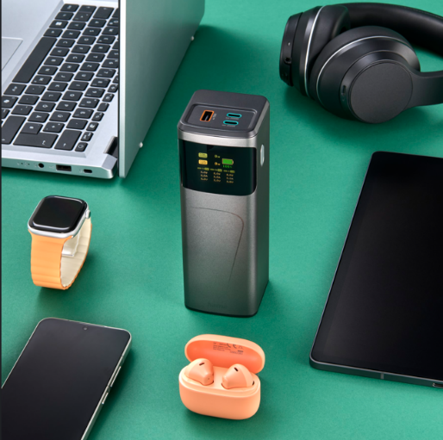
Energy replenishment is usually needed when you are travelling or far away from any power sockets. This can be the case on a train journey, in a business meeting with colleagues or on a weekend trip with the family. With 65, 150 or 200 Watts, the three new power packs from Hama provide enough power to reliably supply a power-hungry notebook, for example, or to connect up to three devices simultaneously to two USB-C and one USB-A sockets.

If only one USB-C port is used on the 200-watt flagship model, 140 watts are available; if two devices are connected, 100 watts are available for each. If all three ports are used, 100 watts go to the first USB-C port, 65 watts to the second, and 18 watts to the USB-A port. A display not only shows the capacity of the power pack itself, but also the output power of the individual charging sockets, so you always have a perfect overview.

Item No. 00201741 Power Pack High Power 65 W, 20,000 mAh,
Phone & Mobile
Smart Home
Wearables
Audio & HiFi
TV Accessories
PC & Laptop
Tablet
Photo & Camera
Living

Contact
Hama GmbH & Co KG
86653 Monheim/Bavaria
Germany
Phone +49 9091 502-0

Your Hama press team
Yasmine Frank (-913)
Tanja Maier (-410)
presse@hama.de
https://company.hama.com/press

2 x USB-C, 1 x USB-A
Item No. 00201742 Power Pack High Power 150 W, 24,000 mAh,
2 x USB-C, 1 x USB-A

Item No. 00201743 Power Pack High Power 200 W, 24,000 mAh,
2 x USB-C, 1 x USB-A

Printable graphics data is available for download in our internet press club
https://company.hama.com/press

