Noise-free radio enjoyment when on holiday

‘DR200BT’ digital radio from Hama

Small, handy and portable; at the same time, reception is noise-free thanks to the latest DAB technology: We’re talking about the new ‘DR200BT’ digital radio from Hama. In addition to digital radio reception with crystal-clear sound, this compact model also offers excellent FM radio reception.
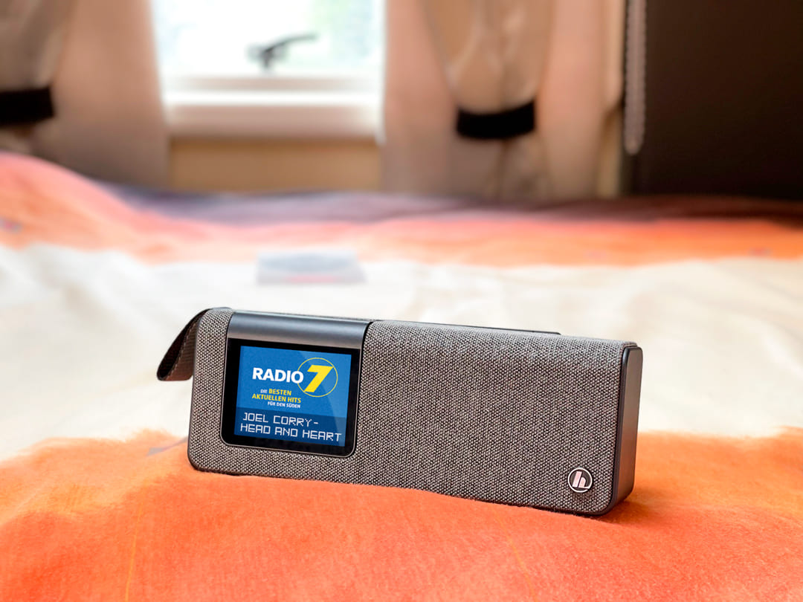The built-in Bluetooth function is quite practical, as it allows the radio to be used in combination with a mobile device, such as a smartphone, tablet, netbook or notebook, for even more musical enjoyment. However, the most useful function of the ‘DR200BT’ may well be the integrated rechargeable battery – it makes the digital radio ideal for a camping holiday. The fact that the radio is operated and charged purely via the USB port – meaning a 230-volt socket is not essential – makes it the perfect companion for holiday trips with the car or caravan. The supplied USB-C cable and your vehicle’s electrical system voltage are all that’s required to operate and to recharge the radio. A battery charge gives about eight hours of music enjoyment. After that, the radio can be recharged with a power pack, for example, and played in the evening as you sit around the campfire.
There are two direct selection buttons for storing and quickly recalling favourite stations; so you don’t have to forego comfort while on holiday. A 2.4-inch colour display simplifies operation and gives this handy digital radio the finishing touch.

Item No. 00173191 "DR200BT" Digital Radio, FM/DAB/DAB+/
Bluetooth/Battery Operation

