uRage "Reaper 800 8K" Gaming Mouse

For fast shooters

uRage introduces the Reaper 800 8K, its first mouse with an 8,000 Hz polling rate. This reduces the response time to 0.125 ms,
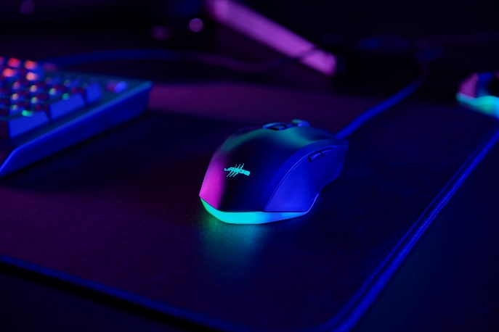
which is important for lovers of fast shooters, as it makes input recognition faster and cursor movements smoother. The symmetrical mouse, which is equally suitable for right-handed and left-handed users, has a native resolution of up to 26,000 dpi thanks to the PAW3395 sensor. The 79-gram lightweight rodent scores points with its durable mouse gliders made of pure PTFE and the detachable and flexible two metre uFlex cable. The practical and programmable four-way scroll wheel enables more extensive use than with conventional mice, while a further eight buttons can be programmed via the gaming software for greater customisation. Lighting, lift-off distance and profiles are saved in the on-board memory and are therefore ready for use at any time.

Item no. 217845 uRage "Reaper 800 8K" gaming mouse

About uRage
The German brand uRage accompanies gamers of all levels with perfectly coordinated accessories. For casual gamers, semi-pros and e-sport teams, uRage offers a broad-based portfolio of keyboards, mice, webcams, microphones and more.
More information can be found at www.urage.com

