Wireless all the way

FM transmitter with Bluetooth and hands-free function

New mobile phone, but old car radio. This prevents you from playing your favourite playlist from your smartphone up and down on the car radio. Hama’s FM transmitter with Bluetooth and hands-free function provides a solution.
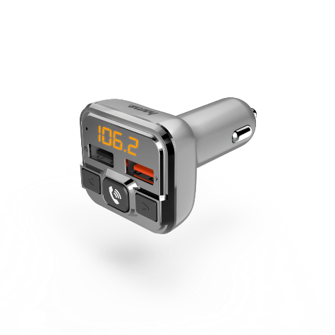
It converts music from the smartphone into radio frequencies, in order that they may be received by the radio and played – thanks to Bluetooth, entirely independently of the connection of the music source. Here, the last FM frequency set is automatically stored. For even more flexibility, music can also be called up via the integrated microSD card or USB slot. A further USB socket is equipped with Qualcomm Quick Charge 3.0 technology, and is suitable for charging mobile devices. The FM transmitter obtains its power from the cigarette lighter.
The built-in hands-free function is likewise practical. When there is an incoming call, the device automatically switches from music to hands-free mode; at the press of a button, the call can then be accepted or ended, or the last number displayed can be dialled.

Item No. 00014165 FM Transmitter with Bluetooth and Hands-Free Function

