LED night light with socket and 2 USB ports

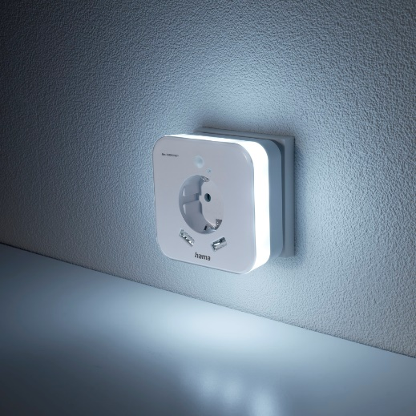
Safe guidance in dark children's rooms, hallways or basements - the LED night light with integrated socket from Hama does not take up any socket space and also offers two additional USB connections. The energy-saving night and orientation light has a built-in motion sensor with a detection angle of around 120 degrees and a range of two and a half metres. Once no more movement is detected, it goes out after 30 seconds. Thanks to two USB-A outputs, it can also supply smartphones, tablets or other devices with power via the USB charging socket. The illumination from the orientation light is daylight white at 18,000 Kelvin, for just 0.3 Watt.

Item No. 223498 LED Night Light with Socket, 2 USB Outputs, Motion and Light Sensor

About Hama
Hama was founded in 1923 and with approximately 18,000 products the company is nowadays one of the leading accessory suppliers in the fields of multimedia, photo, consumer electronics and telecommunications. 1500 people work at the German headquarters in Monheim, Bavaria, about 2500 people are employed all around the world. With 19 sites, numerous sales agencies and its own production facilities Hama is represented all over the world with its high-quality products.
More information at www.hama.com

