

Hama MagPower5 for iPhones with MagSafe

Handy source of power for iPhones

Calling, writing messages, watching videos, taking photos. Even the best smartphone quickly runs out of power without an additional power pack. For iPhones with integrated MagSafe technology, the "MagPower 5" battery pack from Hama is a compact and handy way of boosting that power.

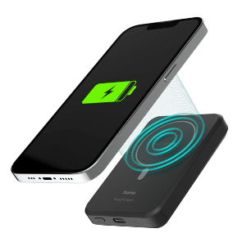
iPhones from Model 12 upwards are equipped with MagSafe technology. Integrated magnets allow accessories such as the new "MagPower5" battery pack from Hama to be docked quickly, easily and safely. This practical function and compact design make it the ideal power provider not just while on the go, but also at home or in the office. The power pack, weighing just 180 grams or so and delivering 5000 mAh, starts wireless charging automatically once the phone is placed on it and the mobile phone is immediately ready for use again. Thanks to the charge-through function, the smartphone and power pack can even be charged simultaneously. In addition to iPhones with MagSafe, "MagPower5" also charges other induction-compatible smartphones, although without the magnet function of course

Item No. 00176638 Smart WLAN Socket, Matter

About Hama
Founded in 1923, Hama today accompanies people in all situations every day with around 18,000 accessory products. Whether it be their smartphone, smart home, smartwatch, TV, audio, computer or photo: every product impresses with high quality, appealing design and innovative functions. The company employs 1,500 people at its German headquarters in Monheim, Bavaria, and around 2,500 worldwide. With 19 foreign locations and numerous commercial agencies, Hama enjoys a global presence. More information can be found at www.hama.com

