Hama "DR40BT-PlugIn" Digital Radio

Compact digital radio for the power socket

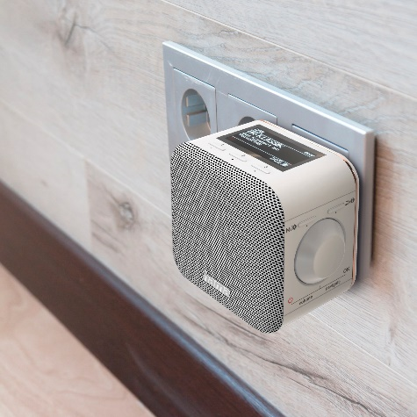
Plug it in and you’re good to go – which basically applies to every radio, although a little differently in this case. Because the “DR40BT” digital radio from Hama is a compact socket radio that is packed with features in the smallest dimensions to avoid taking up unnecessary space. So you can listen not only to DAB or conventional FM stations, but also stream your own playlists off your smartphone, tablet, notebook or PC via Bluetooth. Two hotkeys can also be preset with your favourite radio stations. Just as practical: the socket radio has an alarm function with two memories for an easy way to start the day with your favourite radio station. These can be set to activate as required: once, daily or on the weekend.

Item no. 54871 "DR40BT-PlugIn" Digital Radio

About Hama
Founded in 1923, Hama today accompanies people in all situations every day with around 18,000 accessory products. Whether it be their smartphone, smart home, smartwatch, TV, audio, computer or photo: every product impresses with high quality, appealing design and innovative functions. The company employs 1,500 people at its German headquarters in Monheim, Bavaria, and around 2,500 worldwide. With 19 foreign locations and numerous commercial agencies, Hama enjoys a global presence.
More information can be found at www.hama.com

