Press Information
Phone & Mobile
Smart Home
Smartwatch
Audio & HiFi
TV Accessories
PC & Laptop
Tablet
Photo & Camera
Living

Contact
Hama GmbH & Co KG
86653 Monheim/Bayern
Germany
Phone +49 9091 502-0

Your Hama press team
Susanne Uhlschmidt (-244)
Yasmine Frank (-913)
Tanja Maier (-410)
presse@hama.de
https://company.hama.com/press

April 2025

Fast charging for smartphones, notebooks and more

Flat charger for fast energy

It goes without saying that a USB charger should reliably supply your smartphone, headphones, notebook or other devices with power. It becomes really interesting when it has other impressive features. A new, handy 65 W model from Hama does just that.

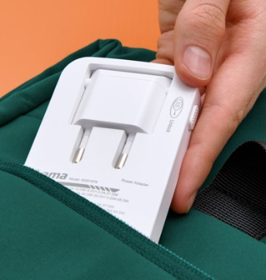
Even at first glance, it is striking: the compact 201976 65 W charger with one USB-A and two USB-C ports is as flat as a smartphone. When the Euro plug is folded down, it really does fit into any trouser or shirt pocket and does not dent a tight-fitting notebook sleeve, for example. The compact USB charger is also a suitable solution when space is tight between the sofa and the wall socket.

Fast charging of multiple devices
Hama's new charger uses gallium nitride, or GaN for short, which not only enables a compact design, but also an efficient and fast power supply. The fast charger supports Power Delivery and Qualcomm Quick Charge 2.0/3.0, automatically recognises the connected devices and charges them gently and safely.

Item No. 201976 Fast Charger, 2x USB-C, 1x USB-A, Flat

Printable graphics data are available for download in our internet press club
https://company.hama.com/press

