Press Information
Phone & Mobile
Smart Home
Smartwatch
Audio & HiFi
TV Accessories
PC & Laptop
Tablet
Photo & Camera
Living

Contact
Hama GmbH & Co KG
86653 Monheim/Bayern
Germany
Phone +49 9091 502-0

Your Hama press team
Susanne Uhlschmidt (-244)
Yasmine Frank (-913)
Tanja Maier (-410)
presse@hama.de
https://company.hama.com/press

Hall 4.2, Booth no. 145



Screen sharing with Hama

Wireless display adapters

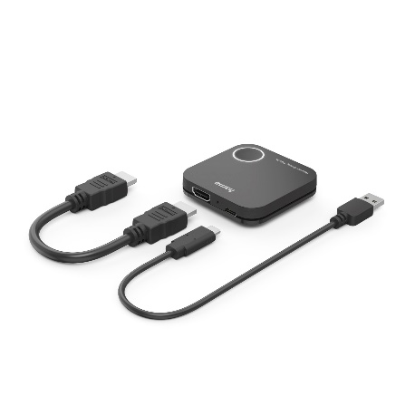
Wireless is the method of choice these days. This also applies to visual transmissions. With the wireless display adapter, Hama presents a small box that sends image and sound signals from a notebook, tablet or smartphone to a second screen or projector. Simply connect the included HDMI and USB-C adapter cable to the receiving device and the display adapter picks up the wireless signals from the transmitting device up to 30 metres away and delivers them at 2.4 GHz or 5 GHz - provided there is a clear line of sight. A normal WLAN signal serves as the basis for this; no additional hardware is required. The pairing of input and output device is controlled via the Screenshare or Miracast function in the settings. Simple and straightforward.
The page orientation is changed at the touch of a button and the adapter receives power from the USB port of the receiving device.

Item No. 00200358 Wireless Display Adapter

Printable graphics data are available for download in our internet press club
https://company.hama.com/press

