Press Information
Phone & Mobile
Smart Home
Smartwatch
Audio & HiFi
TV Accessories
PC & Laptop
Tablet
Photo & Camera
Living

Contakt
Hama GmbH & Co KG
86653 Monheim/Bayern
Germany
Phone +49 9091 502-0

Your Hama press team
Susanne Uhlschmidt (-244)
Yasmine Frank (-913)
Tanja Maier (-410)
presse@hama.de
https://company.hama.com/press

February 2025

Straight, triangular or as a cube

Flexible multiple power strip

Round the corner, as a space-saving cube or as an eye-catcher in the semi-circle around the furniture - the flexible multiple socket from Hama always stays as small or as big as you need it to be. Its innovative design allows space-saving positioning, with the strip being customisable to the environment thanks to the rotating plug elements.
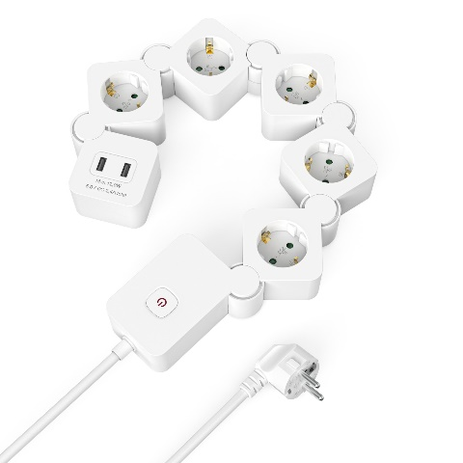
There are almost no limits to its possible uses. With five earthed sockets and two USB outputs, the strip offers a wealth of connection options. The illuminated two-pole switch immediately disconnects the connected devices from the power supply as soon as they are no longer needed. The socket inserts, which are rotated around 45 degrees, create additional space for bulky plugs, power supply units and angled connectors. The strain relief and kink protection on the plug and the mobile socket strip protect against cable breakage, while the increased touch protection guards against accidental contact, e.g. by children

Item No. 223190 Power Strip, 5-Way, USB-A 12 W, Flexible

Printable graphics data are available for download in our internet press club
https://company.hama.com/press

